**AI Assisted Coding - Lab Test 1**

**Q2. Multi-Stage AI Prompting (5M)**

**Prompt 1 :**

Write a Python program that prints the multiplication table of 5

**Code 1:**

# Program to print the multiplication table of 5

number = 5

print(f"Multiplication Table of {number}:")

for i in range(1, 11):

result = number * i

print(f"{number} x {i} = {result}")

**Output 1 :**

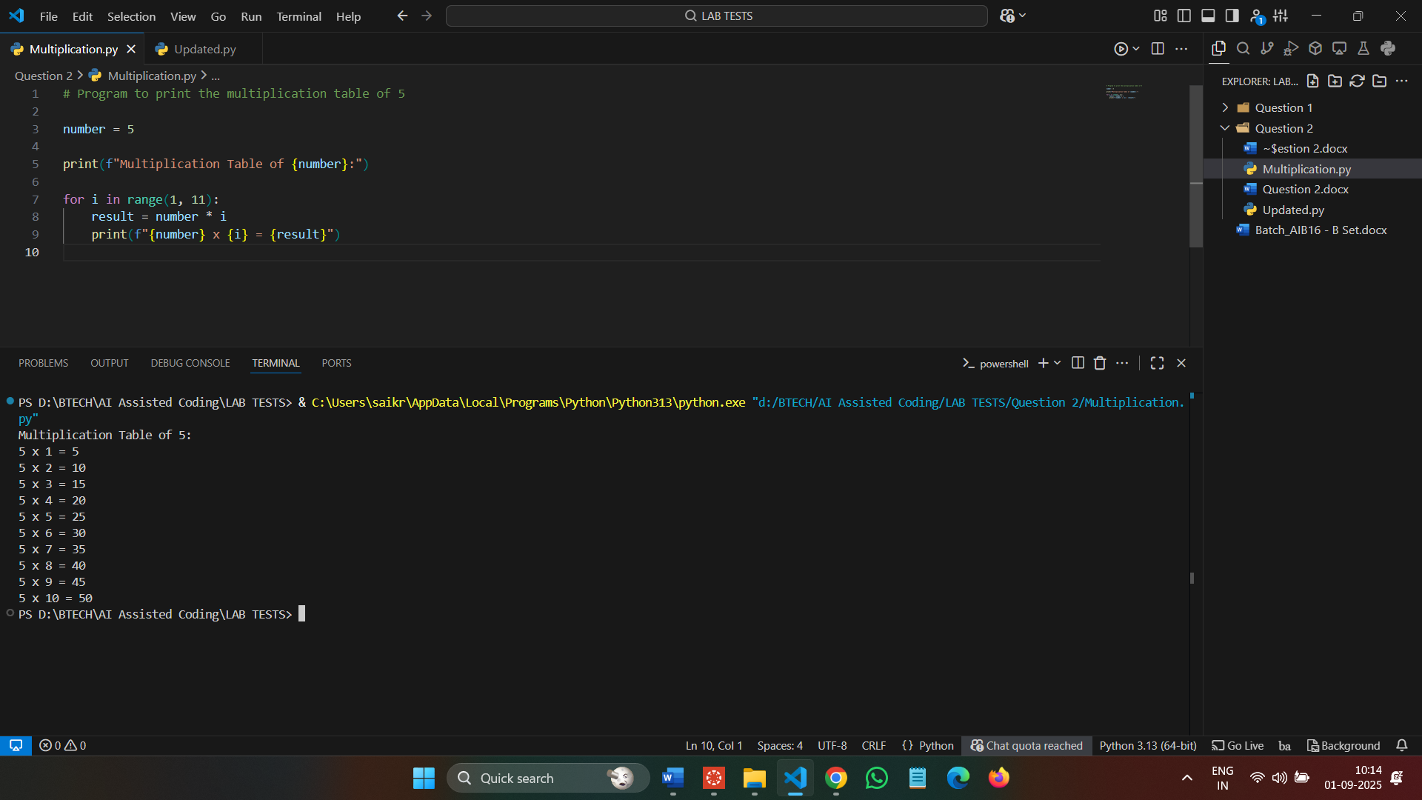

**Prompt 2 :**

Take the previous prompt and ask the user to enter any number greater than 0 and give the multiplication table according to the input

**Code 2 :**

# Program to print the multiplication table of a user-input number

# Ask the user to enter a number greater than 0

number = int(input("Enter a number greater than 0: "))

if number <= 0:

print("Please enter a number greater than 0.")

else:

print(f"\nMultiplication Table of {number}:")

for i in range(1, 11):

result = number * i

print(f"{number} x {i} = {result}")

**Output 2 :**

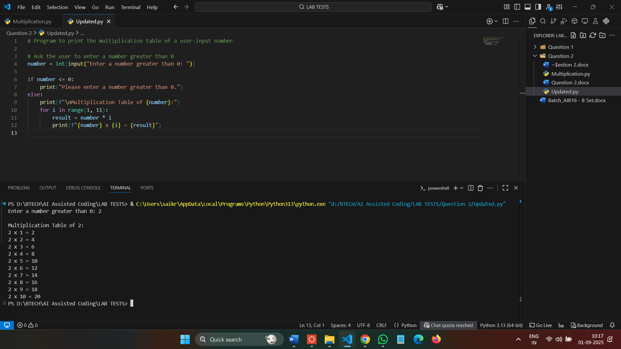

**Observation :**

The program asks the user to enter a number greater than 0 and prints its multiplication table from 1 to 10. It validates the input to ensure it is positive and uses a for loop to generate the table dynamically. The results are displayed in a clear number x i = result format. Overall, the code is simple, readable, and easy to modify for different numbers or ranges.